LAYERS OF THE ATMOSPHERE FOLDABLE
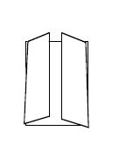
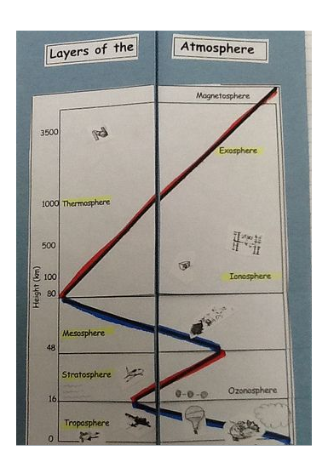
STEP ONE
- Fold a piece of light blue paper in half hamburger bun-style.

STEP TWO
- Open flat and then fold each side toward the center fold – shutter-style.

STEP THREE
- Color the long dark lines that represent temperatures changes: from the bottom – blue, red, blue, red, representing decreasing, increasing, decreasing, increasing temperatures. (see picture to the right)

STEP FOUR
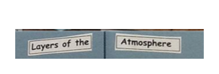
- Carefully cut out the diagram of the atmosphere. Fold in half lengthwise and cut apart. Paste each half onto the front shutters of the light blue paper. Paste toward the bottom so you have room for a title at the top.

STEP FIVE
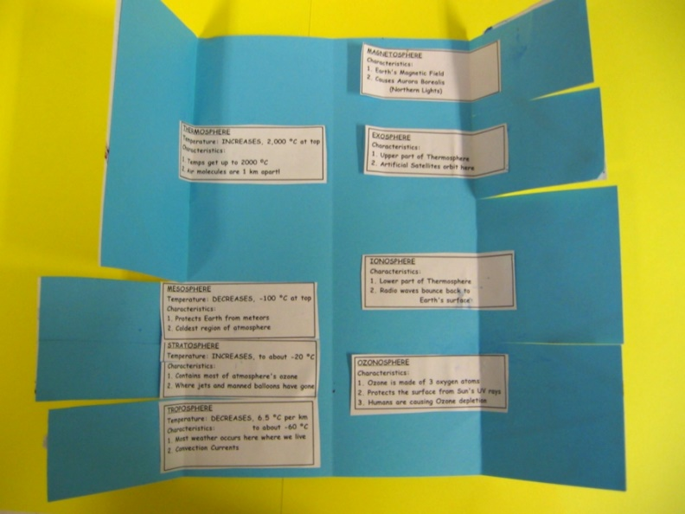
- Cut the two parts of the title out and paste on the top of the shutters.

STEP SIX
- Cut out the boxes that contain the characteristics of each of the eight layers of the atmosphere. Paste inside the foldable under the correct layer. Be sure to put the main layers on the left and minor layers on the inside right.

STEP SEVEN
- Cut the flaps for each of the layers on the front shutters.

STEP EIGHT
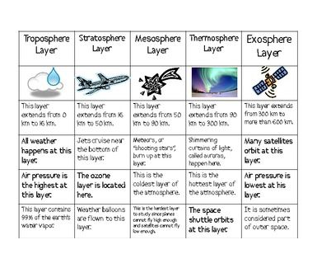
- Carefully cut out the small sketches ONE AT A TIME. Read the words that tell you where to paste the sketch and paste to the foldable on the diagram of the atmosphere. Do NOT cut out the words that tell you where to paste each sketch!

STEP NINE
- Fill in the Name Tag and paste on the back.

**Answer these questions:
- List the four main layers.
- List the four minor layers.
- Which two minor layers are parts of a main layer?
- Which layer is the most important to you and why?
- What two layers protect you?
- Which layer acts like a giant magnet? What does it attract?
- What does the air in the troposphere do as it heats up the sun?
- What cloud indicates the top of the troposphere?
- What runs along the top of the troposphere?
- What attaches itself to this jet stream and, in a sense, tells you where the stratosphere begins?

